OBJECTIVE QUESTIONS:

- In analyzing the hospital dataset with Power BI, ensure data cleaning to address inconsistencies and missing values before further analysis.

Ans: Data Cleaning Steps in Power BI

- Loaded the Data
Imported the datasets Doctors_Patient_Data and Hospitals Data into Power BI.

- Opened Power Query Editor
: Clicked on Transform Data to begin data cleaning.

- Checked for Missing Values
: Scanned all columns to identify null or missing entries.
: Observed missing values in the pat_score column.

- Handled Missing Data
: Replaced null values in pat_score with 0 to maintain consistency.

- Formatted the Data
: Cleaned text fields by removing extra spaces and correcting capitalization.
: Ensured date and time fields were in proper format.

- Verified Data Types
: Checked and corrected data types such as numbers, text, and dates.

- Applied Changes
: Clicked Close & Apply to save and load the cleaned data.

- Assess the Average Waiting Time: Analyse the patient wait times to identify the average duration a patient spends before receiving care.
Ans : Approach
- Calculated Average Waiting Time
: Used a DAX measure to compute the average patient waiting time.
: The overall average waiting time is 35.26 minutes.
: average_wait_time = AVERAGE('Hospital ER (1)'[patient_waittime])
- Created Visualization
: Built a clustered column and line chart:
• Columns represent average waiting time by department
• Line represents average satisfaction score
- Analyzed Department-wise Performance
: Compared waiting time and satisfaction score across departments to identify patterns.

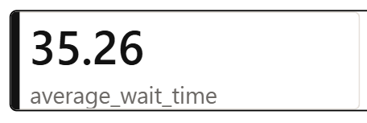
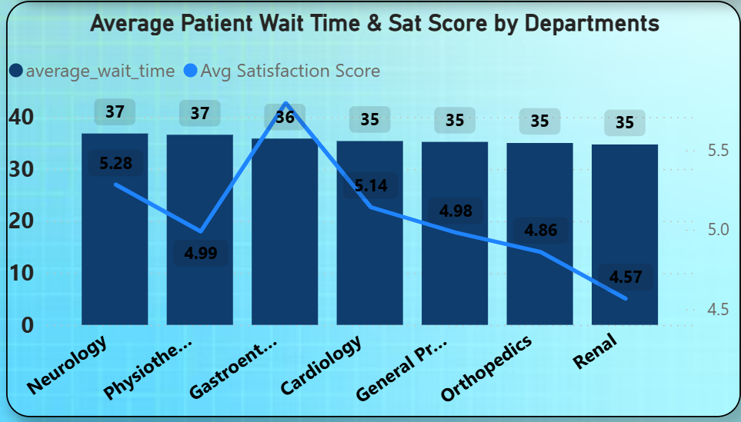

Insights:
- The overall average waiting time is 35.26 minutes, with most departments ranging between 35–37 minutes.
- Neurology and Physiotherapy have slightly higher waiting times (~37 minutes), while other departments remain around 35 minutes.
- Gastroenterology shows the highest satisfaction score (5.36) despite having a similar waiting time.
- Renal has the lowest satisfaction score (4.57) even though its waiting time is not significantly higher.
- This indicates that patient satisfaction is not solely dependent on waiting time; other factors like service quality also play a role.
- The hospital can focus on improving service experience along with reducing waiting time to enhance overall patient satisfaction.

- Visits by Department Referral: Calculate the total number of visits to each department based on referrals to understand which departments are most frequently visited.
Ans : Approach
- Calculated Total Visits
: Created a DAX measure to calculate the total number of patient visits across all departments.
: The total visits recorded are approximately 9K (9,216).
: TotalVisits = COUNTROWS('Hospital ER (1)')
- Created Visualization
: Built a donut chart to show the distribution of visits by department referral.
- Added Summary Card
: Used a card visual to highlight the overall total visits for quick reference.
- Analyzed Department-wise Distribution
: Compared the proportion of visits across different departments.
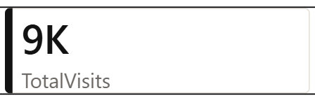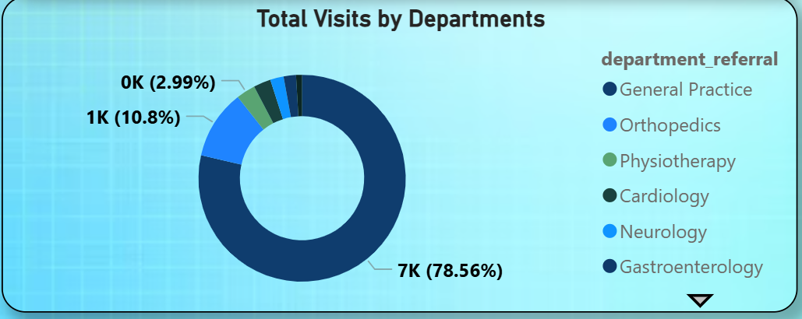
Insights
- The hospital recorded a total of 9,216 visits across all departments.
- General Practice has the highest share with 7K visits (78.56%), indicating it handles the majority of referrals.
- Orthopedics is the second highest with around 1K visits (10.8%).
- Other departments like Physiotherapy, Cardiology, Neurology, and Gastroenterology contribute a very small percentage of total visits.
- This indicates a high concentration of patients in General Practice, leading to an uneven distribution across departments.
- The hospital may consider redistributing workload or optimizing referral processes to balance patient flow.

- Patient Visits by Age Group: Segregate patient visits according to different age groups to see which demographics utilize healthcare services the most.
Ans : Approach
- Created Age Group Column
: Created a calculated column AgeGroup using a SWITCH statement to classify patients into categories (0–17, 18–28, 29–39, 40–59, 60–69, 70+).
: AgeGroup = SWITCH(TRUE,'Hospital ER (1)'[patient_age] < 18,"0-17",
'Hospital ER (1)'[patient_age] < 29,"18-28",
'Hospital ER (1)'[patient_age] < 40,"29-39",
'Hospital ER (1)'[patient_age] < 60, "40-59",
'Hospital ER (1)'[patient_age] < 70, "60-69",
'Hospital ER (1)'[patient_age] >=70, "70+")
- Built Visualization
: Used a column chart to display patient visits by age group.
: X-axis represents AgeGroup and Y-axis represents count of Patient_ID.
- Analyzed Distribution
: Compared the number of visits across different age groups to identify trends.
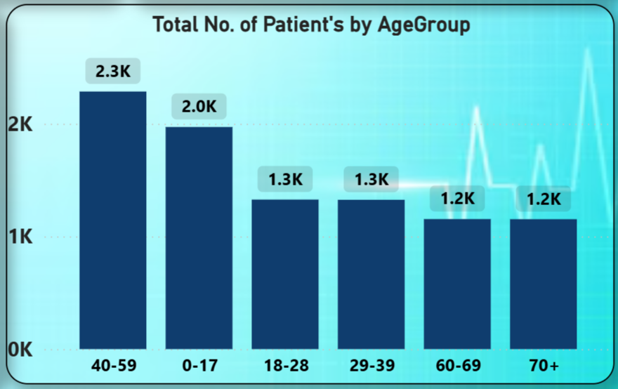
Insights
- The 40–59 age group has the highest visits (2,286), indicating the highest healthcare usage.
- The 0–17 age group follows with 1,971 visits, showing significant usage among younger patients.
- The 18–28 and 29–39 groups each have 1,286 visits, showing moderate usage.
- The 60–69 and 70+ groups each have 1,193 visits, indicating comparatively lower visits.
- Overall, middle-aged and younger populations contribute the most to hospital visits.
- This suggests the hospital should focus more resources on these key age groups while also improving care strategies for older patients.

- Were there any Null values in the data? What would be the best way to handle these Null values and which approach have you opted for?
Ans : Findings :
- Null Value Check
: Most columns in the dataset did not contain missing values.
- Identified Issue
: The patient_sat (Customer Satisfaction) column had a high percentage of null values (72% missing).
- Importance of Column
: This column is important as it reflects patient feedback and helps evaluate service quality.

Approach :
- Evaluation of Options
: Since a large portion of the data was missing, using mean or median imputation could distort the results.
- Chosen Method
: Replaced all null values in patient_sat with 0 to maintain consistency and avoid bias from incorrect assumptions.
- Reasoning
: This approach preserves the dataset structure and avoids misleading interpretations.
General Strategy for Handling Null Values :
- Assess Column Importance
: Determine how critical the column is for analysis.
- Apply Suitable Method
:
• Replace with 0 or “Not Available” for less critical fields
• Use mean, median, or mode for numerical data when appropriate
- Maintain Data Integrity
: Ensure the chosen method does not distort insights or introduce bias.

- Is there any relation between the number of visits and the Gender of the patients?
Ans : Approach
- Created Visualization
: Built a pie chart to represent total patient visits by gender.
- Assigned Data Fields
: Used Patient_Gender as the category and Count of Patient_ID as the value.
- Analyzed Distribution
: Compared the proportion of visits across different gender groups.
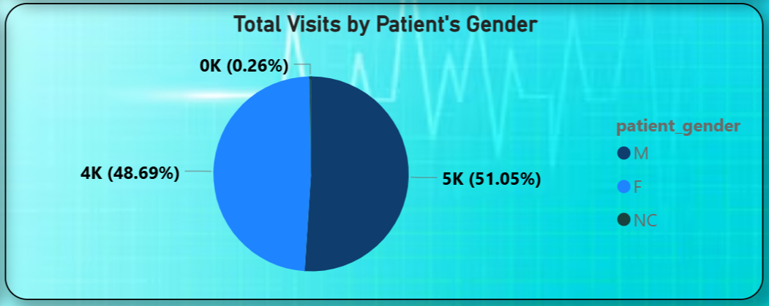
Insights
- Male patients account for 4705 visits (51.05%), slightly higher than females.
- Female patients account for 4487 visits (48.69%), showing a nearly equal share.
- NC (Not Classified) represents only 24 visits (0.26%), which is negligible.
- The difference between male and female visits is minimal, indicating no strong relationship between gender and number of visits.
- Overall, patient visits are evenly distributed across genders, showing balanced healthcare utilization.

- Average Satisfaction by Demographics: Determine the relationship between patient satisfaction scores, their age groups, and racial backgrounds to pinpoint areas for improvement in patient experience.
Ans : Approach
- Created Visualization
: Built a bar chart to analyze patient satisfaction across age groups and racial backgrounds.
- Assigned Data Fields :
• X-axis represents Average Patient Satisfaction Score (PatientSatScore)
• Y-axis represents AgeGroup
• Legend represents Patient_Race
- Analyzed Patterns
: Compared satisfaction scores across different demographic segments to identify trends.
- Data Limitation Note
: Observed that the PatientSatScore column contains around 72% null values, which may affect accuracy.
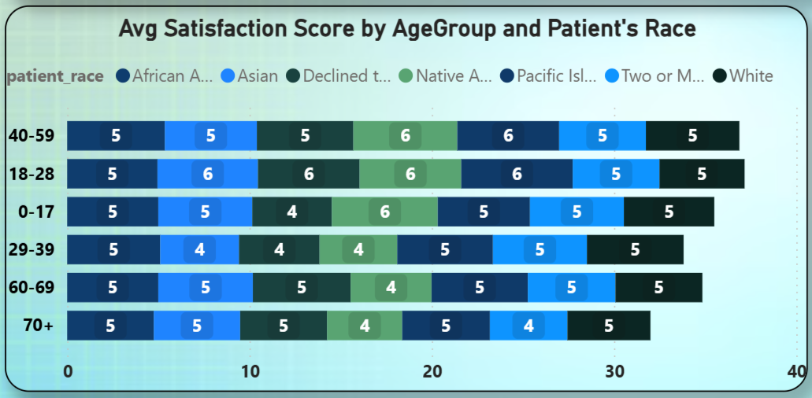
Insights
- Satisfaction scores are generally consistent across age groups and races, mostly ranging between 4 and 6.
- The 18–28 and 40–59 age groups show slightly higher satisfaction in some racial categories.
- Some groups (e.g., 29–39 and 70+) show slightly lower scores in certain categories, but differences are minimal.
- Overall, there is no strong variation or clear pattern in satisfaction based on age or race.
- Due to the high percentage of missing data (72%), these insights may not fully reflect actual patient experience.
- The hospital should focus on improving feedback collection to generate more reliable and actionable insights.

- The hospital's managing director seeks to evaluate the revenue of each department to understand how much revenue is generated by each.
Ans: Approach
- Calculated Total Revenue
: Created a DAX measure to calculate total revenue generated by each department.
: Total Revenue = SUM(doctor_patients_data[Total Bill])
- Created Visualization
: Used a bar chart to display revenue distribution across departments.
: X-axis represents TotalRevenue
: Y-axis represents Department_Referral
- Analyzed Performance
: Compared revenue contribution of each department to identify top performers.
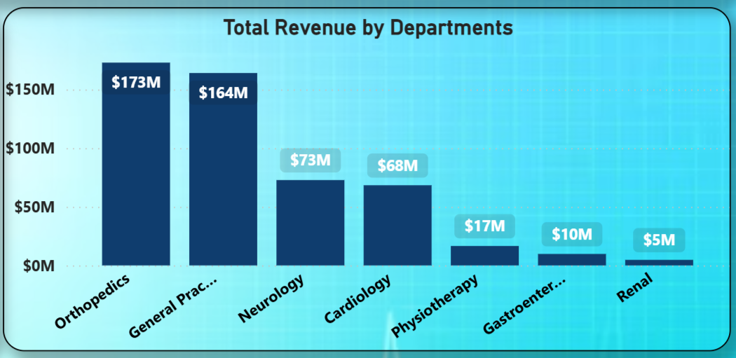
Insights
- Orthopedics generated the highest revenue (₹173M), making it the top-performing department.
- General Practice follows closely with ₹164M, contributing significantly to overall revenue.
- Neurology (₹73M) and Cardiology (₹68M) show moderate revenue contribution.
- Physiotherapy (₹17M), Gastroenterology (₹10M), and Renal (₹5M) generate comparatively lower revenue.
- The majority of revenue is concentrated in Orthopedics and General Practice, indicating high demand for these services.
- The hospital may explore strategies to improve performance in lower-revenue departments while maintaining efficiency in top-performing ones.

- Which department is charging the highest appointment fees in general? Use an aggregation DAX function to solve this question.
Ans: Approach
- Calculated Maximum Fee
: Created a DAX measure using an aggregation function to find the highest appointment fee.
: Highest Appointment Fees = MAX(doctor_patients_data[Appointment Fees])
- Identified Department
: Created another DAX measure to determine which department corresponds to the highest fee.
: DepartmentWithHighestFee =
VAR MaxFee = [HighestAppointmentFees]
RETURN
CALCULATE(
SELECTEDVALUE(Sheet1[Department_Referral]),
Sheet1[Appointment Fees] = MaxFee)

- Combined Analysis
: Used both measures together to identify the maximum fee along with its respective department.

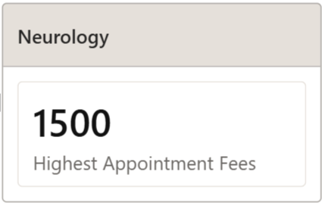
Insights
- The Neurology department has the highest appointment fee ($1,500).
- This suggests that Neurology services may involve specialized or complex treatments, leading to higher charges.
- Compared to other departments, Neurology appears to be a premium service area in terms of pricing.
- The hospital can further analyze whether higher fees impact patient volume or satisfaction in this department.

- Create a tabular visualization in the Report view which consists of Month-wise total visits in the hospital. Add a third column in the table that consists of the previous month’s total visits for each month’s row. Also, include a column that states whether the visits in a month are greater than that of the previous month's visits.
Ans: Approach
- Calculated Total Visits
: Created a DAX measure TotalVisits to calculate the total number of patient visits for each month.
: TotalVisits = COUNTROWS('Hospital ER (1)')

- Retrieved Previous Month Visits
: Created a measure LastMonthVisits to get the total visits from the previous month (similar to a LAG function).
: LastMonthVisits =
VAR CurrentMonth =
MAX ('Hospital ER (1)'[MonthNumber] )
RETURN
CALCULATE (
[TotalVisits],
FILTER (
ALL ( 'Hospital ER (1)' ),
'Hospital ER (1)'[MonthNumber] = CurrentMonth - 1))

- Compared Monthly Changes
: Created a measure IncreaseComparedToPrevious to compare current month visits with the previous month and identify increases.
: Increase from Previous Month = IF([TotalVisits] > [LastMonthVisits],"Yes","No")

- Created Visualization
: Built a table showing Month, TotalVisits, LastMonthVisits, and IncreaseComparedToPrevious for clear comparison.
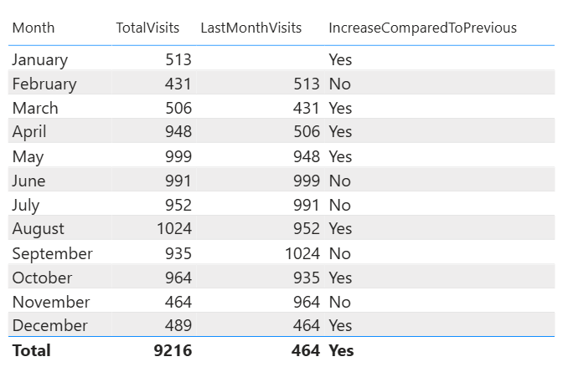
Insights
- Patient visits show a fluctuating trend throughout the year.
- There is a slight decline from January to February, possibly due to post-holiday effects.
- A steady increase from March to May is observed, with May recording the highest visits (999).
- Visits decline slightly in June and July, followed by a rise again in August (1,024 visits).
- The lowest number of visits occurs in November (464), indicating reduced activity toward year-end.
- Overall, the pattern suggests a seasonal or cyclical trend, which can help in planning staffing and hospital resources effectively.

- Using ‘Calculate’ and a row iteration DAX function calculate the total number of patients who have visited Dr. Smith.
Ans : Approach
- Applied Filter Using DAX
: Used the CALCULATE function to filter data specifically for “Dr. Smith”.
- Counted Patient Visits
: Used the COUNTA function to count the number of patient visit entries for Dr. Smith.
- Created Measure
: Combined CALCULATE and COUNTA to create a measure that returns total visits for Dr. Smith.
: Dr Smiths Total Patients = CALCULATE(COUNTA(doctor_patients_data[patient_id]),
doctor_patients_data[Doctor Name] = "Dr. Smith")
- Displayed Result
: Used a card visualization to show the total number of visits clearly.

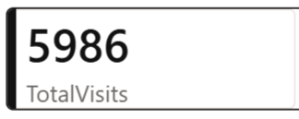
Insights
- Dr. Smith recorded a total of 5,986 patient visits, indicating a high number of consultations.
- This suggests strong patient trust, experience, or specialization in Dr. Smith’s services.
- Compared to others, Dr. Smith appears to have a higher workload, which may require better scheduling support.
- The hospital can use this insight for resource planning and workload distribution among doctors.

- Calculate the average age of the patients who visit the Orthopedics department. Will the approach used to calculate this metric be different if the requirement had been all departments’ average age?
Ans : Approach
- Calculated Average Age for Orthopedics
: Created a DAX measure using CALCULATE to filter only the Orthopedics department and compute the average age.
: Orthopedics Avg Age = CALCULATE(AVERAGE('Hospital ER (1)'[patient_age]),'Hospital ER (1)'[department_referral] = "Orthopedics")
- Modified for All Departments
: Yes, the approach is slightly different when calculating for all departments.
- Used ALL() Function
: Applied the ALL() function to remove department-level filters and calculate the overall average age across all departments.
- Created Final Measures
: One measure for Orthopedics-specific average and another for overall average ignoring filters.
: Avg Age Across All Dep = CALCULATE(AVERAGE('Hospital ER (1)'[patient_age]),ALL('Hospital ER (1)'))
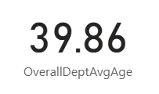
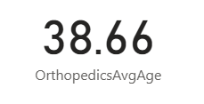

Insights
- The average age in the Orthopedics department is 38.66 years.
- The overall hospital average age is 39.86 years.
- Orthopedics patients are slightly younger than the overall patient population.
- This suggests that middle-aged individuals are more likely to seek orthopedic care for bone or joint-related issues.
- These insights can help in targeted treatment planning and resource allocation for specific age groups.
- Were there any data format issues in the data, and if there were/are how you handle them?
Ans : Approach
- Identified Format Issues
: Checked the dataset for inconsistencies such as incorrect date formats, numeric mismatches, and text irregularities.
- Standardized Date/Time Formats
: Converted date columns into a proper Date/Time format using Power Query (Change Type) or DAX functions like DATEVALUE() and FORMAT().
- Corrected Numeric and Currency Formats
: Ensured numeric fields were set to appropriate data types such as Decimal Number or Whole Number for accurate calculations.
- Cleaned Text Data
: Used functions like UPPER(), LOWER(), and PROPER() to maintain consistent text formatting.
- Handled Blank or Null Values
: Replaced or managed missing values using Power Query (Replace Values) or DAX functions like IF(ISBLANK()).
- Ensured Data Consistency
: Verified that all columns had correct data types and consistent formatting across the dataset.
Outcome
- The dataset became clean and standardized, reducing errors during analysis.
- Consistent formatting improved data accuracy and reliability.
- Proper handling of formats ensured smooth calculations and visualizations in Power BI.
- Overall, the data was prepared for efficient and error-free analysis.

- When we add a column in Power Query what’s the code that comes in M language in the formula bar? What do you know about M-query?
Ans : Approach
- Column Creation in Power Query
: When a new column is added, Power Query generates M code using the Table.AddColumn function.
Example:
= Table.AddColumn(#"Previous Step", "New Column", each [Column1] + [Column2])
- Explanation of Syntax
: #"Previous Step" refers to the last applied step.
: "New Column" is the name of the column being created.
: each defines the row-level calculation logic.

About M Query :
- Definition : M Query is the language used in Power Query to transform and prepare data.
- Working Style : It follows a step-by-step execution, where each step builds on the previous one.
- Role in Power BI : It is mainly used for data extraction, transformation, and loading (ETL).
- Where to Access : M code can be accessed and modified using the Advanced Editor in Power Query.
- Common Functions :
• Table.AddColumn
• Table.FilterRows
• Table.Sort
• Table.RemoveColumns
Insights :
1. M Query is essential for preparing clean and structured data.
2. It helps automate data transformation processes.
3. Understanding M improves data handling efficiency in Power BI.

- Identify the top 5 doctors who generated the most revenue but had the fewest patients. (SQL)
Ans :
SQL Query :

SELECT Doctor_Name, SUM(Total_Bill) AS Total_Revenue, COUNT(DISTINCT patient_id) AS No_of_patients
FROM doctor_patients_data
GROUP BY Doctor_Name
ORDER BY Total_Revenue DESC, No_of_patients ASC
LIMIT 5;
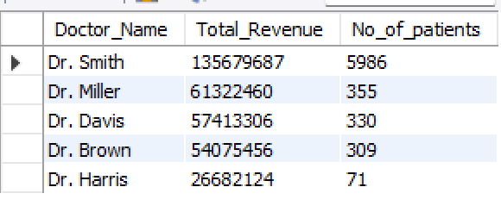

- Find the department where the average waiting time has decreased over three consecutive months. (SQL)
Ans : Approach
- Calculated Monthly Average Wait Time
: Used AVG() and GROUP BY to calculate the average patient waiting time for each department by month.
- Used Window Function
: Applied the LAG() function to retrieve average waiting times from the previous two months for each department.
- Compared Consecutive Months
: Filtered departments where the current month’s average waiting time was lower than both previous months, showing a continuous decrease.
- Displayed Required Departments
: Selected distinct department names that satisfied the decreasing trend condition.

SQL Query :
WITH mycte AS (
SELECT
department_referral,
EXTRACT(MONTH FROM date) AS month_num,
AVG(patient_waittime) AS current_month_avg_time
FROM hospital_er
GROUP BY department_referral, EXTRACT(MONTH FROM date)
),
mycte2 AS (
SELECT
department_referral,
month_num,
current_month_avg_time,
LAG(current_month_avg_time,1) OVER(
PARTITION BY department_referral
ORDER BY month_num
) AS prev_month_avg_time,
LAG(current_month_avg_time,2) OVER(
PARTITION BY department_referral
ORDER BY month_num
) AS prev_2month_avg_time
FROM mycte
)
SELECT DISTINCT department_referral
FROM mycte2
WHERE current_month_avg_time < prev_month_avg_time
AND prev_month_avg_time < prev_2month_avg_time;
- Determine the ratio of male to female patients for each doctor and rank the doctors based on this ratio. (SQL)
Ans :
SQL Query :

SELECT Doctor_Name, male_count, female_count, male_count / female_count AS male_female_ratio,
RANK() OVER (ORDER BY male_count / female_count DESC) AS doctor_rank
FROM (SELECT d.Doctor_Name,
SUM(CASE WHEN h.patient_gender = 'M' THEN 1 ELSE 0 END) AS male_count,
SUM(CASE WHEN h.patient_gender = 'F' THEN 1 ELSE 0 END) AS female_count
FROM doctor_patients_data d
JOIN hospital_er h
ON d.patient_id = h.patient_id
GROUP BY d.Doctor_Name) t
WHERE female_count > 0;
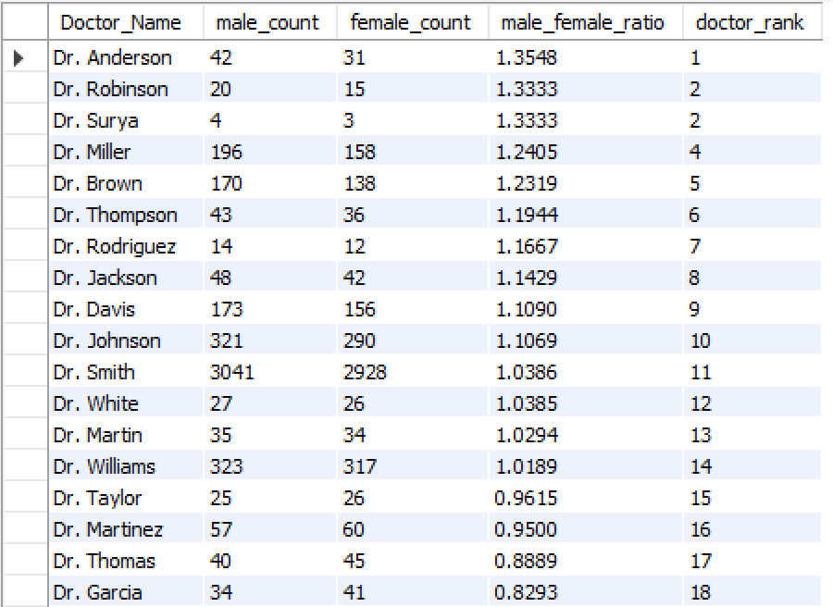

- Calculate the average satisfaction score of patients for each doctor based on their visits. (SQL)
Ans :
SQL Query :

SELECT d.Doctor_Name, ROUND(AVG(h.patient_sat_score), 2) AS avg_satisfaction_score, COUNT(DISTINCT h.patient_id) AS Total_Visits
FROM doctor_patients_data d
JOIN hospital_er h
ON d.patient_id = h.patient_id
GROUP BY d.Doctor_Name;
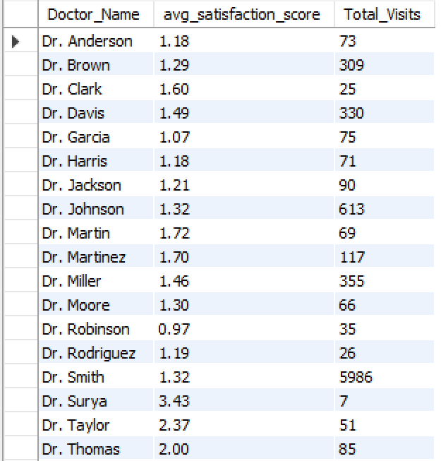

- Find doctors who have treated patients from different races and calculate the diversity of their patient base. (SQL)
Ans :
SQL Query :

SELECT d.Doctor_Name, COUNT(DISTINCT h.patient_race) AS Total_race_diversity_count
FROM doctor_patients_data d
JOIN hospital_er h
ON d.patient_id = h.patient_id
WHERE h.patient_race IS NOT NULL
GROUP BY d.Doctor_Name
HAVING COUNT(DISTINCT h.patient_race) > 1;
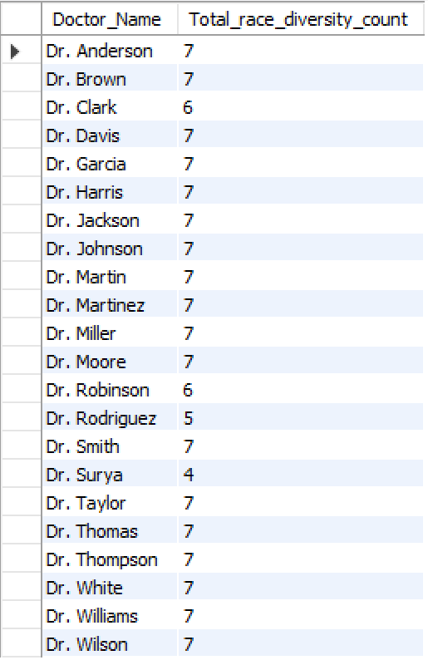

- Calculate the ratio of total bills generated by male patients to female patients for each department. (SQL)
Ans :
SQL Query :

WITH cte1 AS (SELECT d.department_referral,
SUM(CASE WHEN h.patient_gender = 'M' THEN d.Total_Bill ELSE 0 END) AS male_total_bill,
SUM(CASE WHEN h.patient_gender = 'F' THEN d.Total_Bill ELSE 0 END) AS female_total_bill
FROM doctor_patients_data d
JOIN hospital_er h
ON d.patient_id = h.patient_id
GROUP BY d.department_referral)
SELECT department_referral, male_total_bill, female_total_bill,
ROUND(male_total_bill / female_total_bill, 2) AS male_female_bill_ratio
FROM cte1
WHERE female_total_bill > 0;
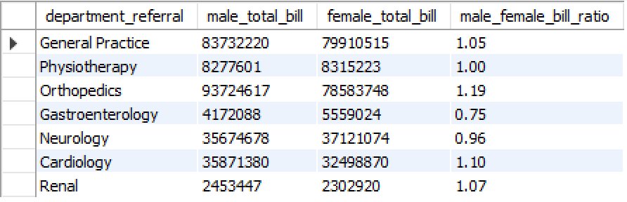

- Update the patient satisfaction score for all patients who visited the "General Practice" department and had a waiting time of more than 30 minutes. Increase their satisfaction score by 2 points, but ensure that the satisfaction score does not exceed 10. (SQL)
Ans : Approach
- Created a New Column
: Added a new column updated_sat_score instead of modifying the original satisfaction score to maintain data integrity and allow easy comparison.
- Applied Conditional Update
: Updated scores only for patients from the General Practice department with patient_waittime > 30 minutes.
- Handled Null Values
: Used COALESCE() to replace null satisfaction scores with 0 before performing calculations.
- Restricted Maximum Score
: Used LEAST() to ensure the updated satisfaction score does not exceed 10.
- Validated Results
: Queried both old and updated satisfaction scores for verification.

SQL Query :

ALTER TABLE hospital_er
ADD COLUMN updated_sat_score DECIMAL(5,2);
UPDATE hospital_er
SET updated_sat_score =
CASE
WHEN LOWER(department_referral) = 'general practice'
AND patient_waittime > 30
THEN LEAST(COALESCE(patient_sat_score,0) + 2, 10)
ELSE COALESCE(patient_sat_score,0)
END;
SELECT
department_referral,
patient_waittime,
COALESCE(patient_sat_score,0) AS old_sat_score,
updated_sat_score
FROM hospital_er
WHERE department_referral = 'General Practice';

Insights
- The query increases satisfaction scores for patients who experienced longer waiting times in the General Practice department.
- Using a separate column preserves the original dataset and supports comparison between old and updated values.
- The use of COALESCE() and LEAST() ensures clean, consistent, and valid data updates.
- This approach can help simulate a compensation strategy to improve patient experience after delays.

Subjective Questions

- What is the relation between patient wait time and satisfaction scores?
Ans : Approach
- Calculated Satisfaction Score
: Created a DAX measure to calculate the average patient satisfaction score.
: Avg Satisfaction Score = AVERAGE('Hospital ER (1)'[patient_sat_score])

- Built Visualization
: Used a scatter plot to analyze the relationship:
: X-axis represents Patient Wait Time
: Y-axis represents Average Satisfaction Score
- Added Trendline
: Included a trendline from the Analytics pane to observe correlation between variables.
- Handled Missing Data
: Replaced null values in satisfaction scores (around 72%) with 0, which may slightly impact the results.
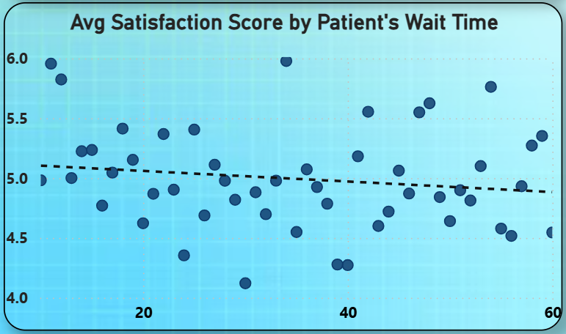
Insights
- The trendline indicates a slight negative relationship, where higher wait times are associated with lower satisfaction.
- Some data points show high satisfaction despite longer wait times, suggesting other factors like service quality influence patient experience.
- The replacement of missing values with 0 may lower the overall satisfaction average, slightly exaggerating the negative trend.
- Overall, wait time has an impact, but it is not the only factor affecting patient satisfaction.

Recommendations
- Improve appointment scheduling and queue management to reduce waiting time.
- Enhance patient communication regarding expected wait times.
- Improve data collection for satisfaction scores to reduce missing values and increase accuracy.
- Perform department-level analysis to identify areas with stronger impact and target improvements.

- How do patient demographics affect the frequency of visits to different departments?
Ans : Approach
- Created Visualization
: Built a column and line combo chart in Power BI to analyze visit patterns.
- Assigned Data Fields
: X-axis represents Department_Referral
: Column values represent Count of Patient_ID (visit frequency)
: Legend represents AgeGroup (demographic segmentation)
: Line values represent Sum of Total Bill (spending trend)
- Focused on Key Demographic
: Used AgeGroup as the primary demographic factor, as it showed more variation compared to gender.
- Analyzed Patterns
: Compared visit frequency and billing trends across departments and age groups.
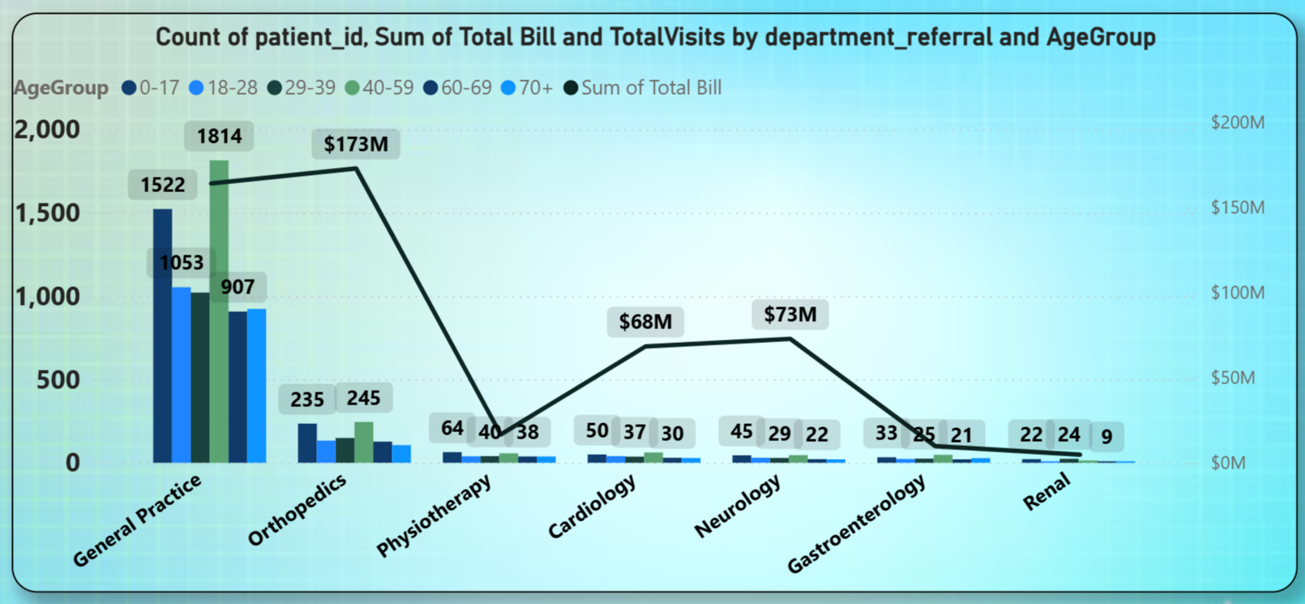
Insights
- General Practice has the highest visits across all age groups, especially 29–59 and 60–69, making it the main entry point for patients.
- Orthopedics shows high visits mainly from 40–69 age groups, indicating age-related bone and joint issues.
- Cardiology and Neurology have fewer visits but higher total bills, suggesting specialized and costly treatments.
- Younger patients (0–28) mostly visit General Practice, while older patients are more concentrated in Orthopedics and Neurology.
- Age plays a significant role in determining department preference and healthcare needs.

Recommendations
- Resource Allocation
: Increase staffing and capacity in General Practice and Orthopedics due to high patient volume.
- Preventive Healthcare Programs
: Introduce age-specific programs such as regular checkups for adults and preventive care for seniors.
- Cost Optimization
: Review pricing and efficiency in high-cost departments like Neurology and Cardiology.
- Expand Analysis
: Include additional demographics like gender and race for deeper insights in future analysis.

- Is there a noticeable trend in the volume of patient visits throughout the year?
Ans : Approach
- Created Visualization
: Built a column and line combo chart in Power BI to analyze monthly patient visits.
- Assigned Data Fields
: X-axis represents Month (with Year) for a continuous timeline.
: Column values represent TotalVisits for each month.
: Line values represent TotalVisits to highlight the overall trend.
- Sorted Data
: Ensured the time data was arranged chronologically for accurate trend analysis.
- Analyzed Trends
: Compared visit volumes across months and years to identify patterns.
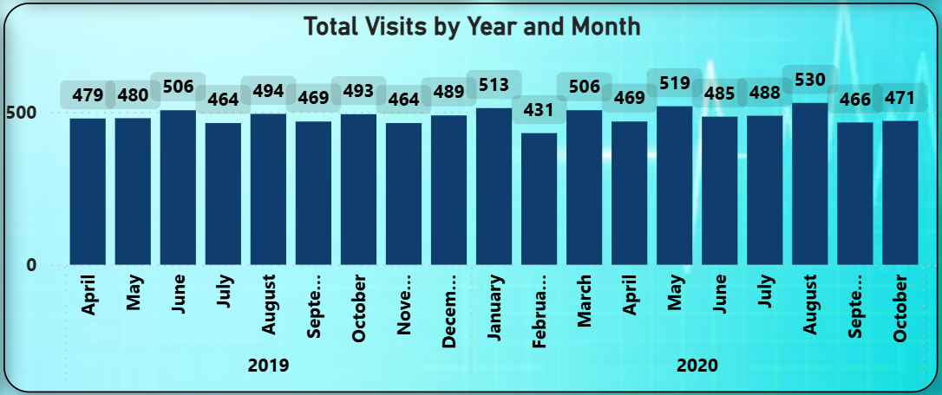
Insights
- Patient visits show moderate fluctuations throughout the year without extreme spikes.
- A slight dip in February is observed, possibly due to fewer working days or seasonal factors.
- The highest visits were recorded in August 2020 (530 visits), indicating a mid-year peak.
- Monthly visits generally remain stable between 470 and 510, showing consistent patient flow.
- There is a slight increase in 2020 compared to 2019, suggesting improved patient engagement or outreach.

Recommendations
- Capacity Planning
: Maintain consistent staffing levels with slight adjustments during peak months like August.
- Analyze February Decline
: Investigate possible causes such as holidays, weather, or scheduling patterns.
- Prepare for Fluctuations
: Ensure readiness for minor increases during peak periods.
- Track Growth Trends
: Continue monitoring year-on-year trends to evaluate hospital performance and patient growth.

- Which age groups report the highest and lowest satisfaction scores?
Ans : Approach
- Calculated Average Satisfaction
: Created a DAX measure to compute the average patient satisfaction score (avg_sat_score).
: Avg Satisfaction Score = AVERAGE('Hospital ER (1)'[patient_sat_score])

- Created Visualization
: Used a column chart to display satisfaction scores across age groups.
: X-axis represents AgeGroup
: Y-axis represents avg_sat_score
- Added Data Labels
: Displayed exact values on the chart for better clarity and comparison. 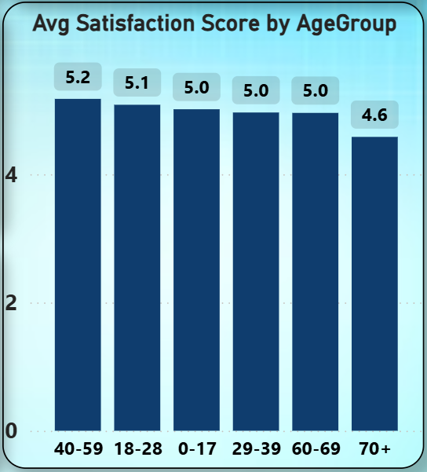
Insights
- The 40–59 age group has the highest satisfaction score (5.2).
- The 18–28 group follows with a score of 5.1.
- The 0–17, 29–39, and 60–69 groups all have similar satisfaction scores (5.0).
- The 70+ age group has the lowest satisfaction score (4.6).
- Satisfaction slightly declines with increasing age, especially for senior patients.

Recommendations
- Improve Elderly Patient Experience
: Focus on better support, communication, and faster service for the 70+ age group.
- Maintain High Satisfaction Levels
: Continue current practices that work well for middle-aged and younger patients.
- Targeted Improvements
: Identify specific concerns of older patients through feedback and improve service quality.
- Enhance Feedback Collection
: Ensure more consistent and accurate data collection for better future analysis.

- Say someone outside of the hospital claims that there is racial or gender-based discrimination in the hospital, how will you identify whether the claim was right or not?
Ans : Approach
- Analyzed Wait Time by Demographics
: Created a measure for average wait time.
: Used a clustered column chart with:
: X-axis as Patient Race, Legend as Patient Gender, and Value as Average Wait Time.
: average_wait_time = AVERAGE('Hospital ER (1)'[patient_waittime])
- Evaluated Admission Rates
: Created measures to calculate admission rates.
: Used a 100% stacked column chart to compare admission rates across race and gender.
: Admission Count = CALCULATE(COUNTROWS('Hospital ER (1)'),'Hospital ER (1)'[patient_admin_flag]= TRUE())
: Admission Rate = DIVIDE([Admission Count],[TotalVisits])

- Compared Revenue and Satisfaction
: Created measures for total revenue and average satisfaction score.
: Used a combo chart:
: Columns represent Total Revenue
: Line represents Average Satisfaction Score
: Legend represents Patient Gender
: avg_sat_score = AVERAGE('Hospital ER (1)'[patient_sat_score])
: TotalRevenue = SUM(doctor_patients_data[Total Bill])

- Checked Visit Distribution
: Used a donut chart to analyze total visits by race to understand representation and accessibility.
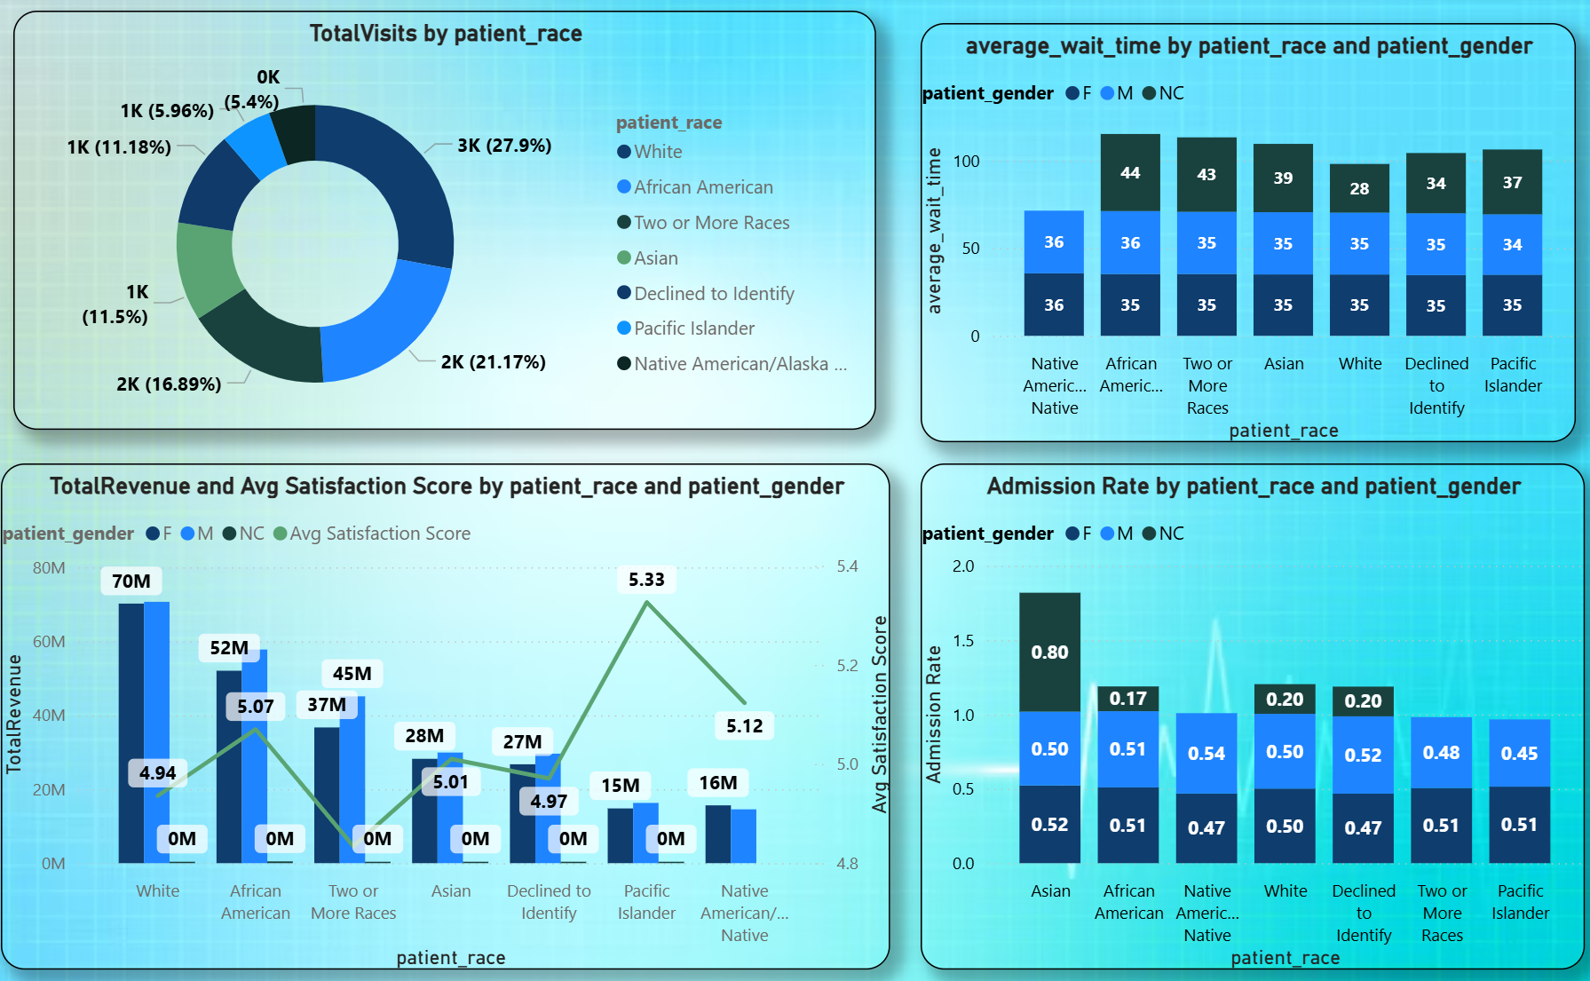

Insights
- Wait Time
: Average wait time is consistent (34–36 minutes) across all races and genders.
- Admission Rate
: Admission rates are balanced (48%–53%) across all demographic groups.
- Revenue & Satisfaction
: Satisfaction scores are stable (around 4.9–5.3) across races.
: Revenue distribution is proportional to visit volume, not biased by demographics.
- Visit Distribution
: Majority visits come from White (27.9%) and Asian (21.1%), with other groups also well represented.
: No evidence of exclusion or restricted access.
- Overall Conclusion
: No strong evidence of racial or gender-based discrimination.
: Observed differences are minor and within normal operational variation.

Recommendations
- Continuous Monitoring
: Track fairness metrics (wait time, admission rate, satisfaction) regularly.
- Department-Level Review
: Audit departments where small variations exist.
- Improve Feedback Collection
: Collect more detailed satisfaction data across all groups.
- Bias Awareness Training
: Conduct regular training to minimize unconscious bias.
- Transparent Reporting
: Publish periodic fairness reports to maintain trust and accountability.

- The hospital management intends to offer discounts to patients. How should these offers/discounts be assigned to patients, on what basis, and why?
Ans : Approach
- Analyzed Key Metrics
: Evaluated Total Revenue, Total Visits, and Average Appointment Fees across AgeGroups to understand patient contribution and engagement.
- Created DAX Measures
: Calculated measures for:
: Total Revenue → overall income generated
: TotalRevenue = SUM(doctor_patients_data[Total Bill])
: Average Appointment Fees → average consultation cost
:AvgAppointmentFess = AVERAGE(doctor_patients_data[Appointment Fees])
Total Visits → frequency of visits
: TotalVisits = COUNTROWS('Hospital ER (1)')

- Built Visualization
: Used a combo chart to compare revenue, visits, and fees across AgeGroups.
- Segmented Discount Categories
: Classified patients into High, Medium, and No Discount categories based on performance.
: DiscountCategory =
SWITCH(
TRUE(),
'Hospital ER (1)'[AgeGroup] IN {"40-59", "0-17"}, "High",
'Hospital ER (1)'[AgeGroup] IN {"60-69", "70+"}, "Medium",
"No Discount")
- Defined Eligibility
: Created a condition-based column to identify eligible patients for discounts.
: EligibleForDiscount =
IF(
(
'Hospital ER (1)'[patient_age] >= 40
&& 'Hospital ER (1)'[patient_age] <= 59
)
|| 'Hospital ER (1)'[patient_age] < 18, "Yes","No")

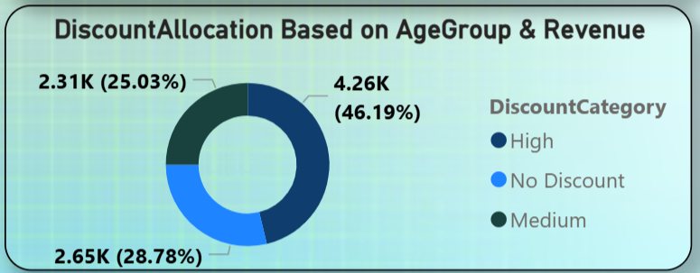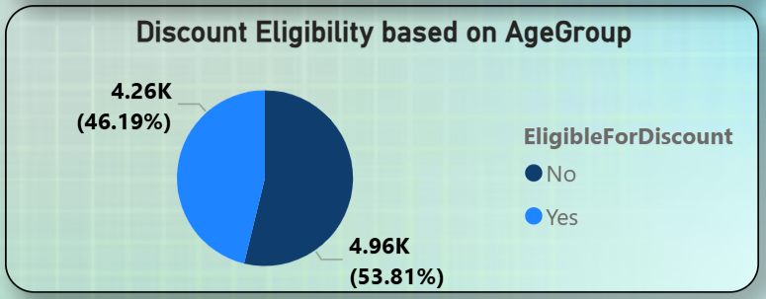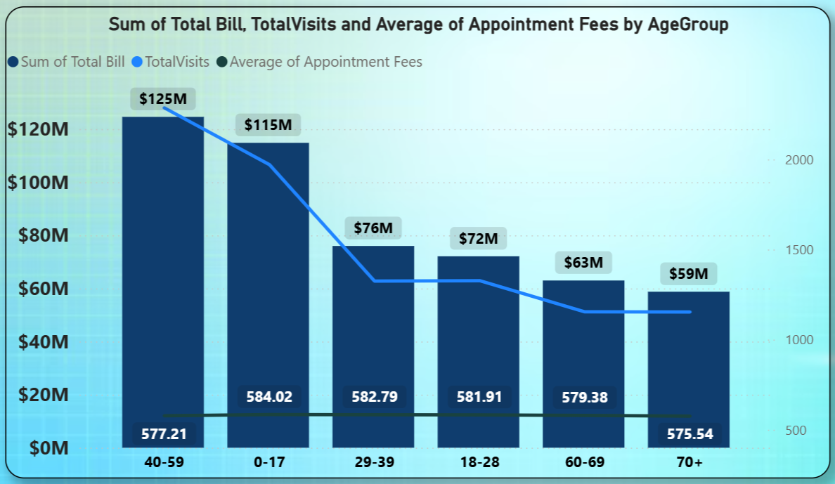
Insights
- 40–59 and 0–17 age groups generate the highest revenue ($125M and $115M) and have the highest visits → strong engagement.
- 29–39 and 18–28 groups show moderate revenue ($76M and $72M) → moderate engagement.
- 60–69 and 70+ groups generate the lowest revenue ($63M and $59M) and fewer visits → low engagement.
- From the distribution:
: 46.19% fall under High Discount
: 25.03% under Medium Discount
: 28.78% under No Discount
- 53.81% of patients are eligible for discounts, indicating a need to boost engagement in lower-performing groups.

Conclusion (Discount Strategy)
- High Discounts (15–20%)
: Applicable for 60–69 and 70+ age groups.
: Aim to increase visits and encourage preventive care.
- Medium Discounts (around 10%)
: Applicable for 18–28 and 29–39 groups.
: Aim to improve engagement and visit frequency.
- No or Low Discounts
: Applicable for 0–17 and 40–59 groups.
: These groups already generate high revenue and visits.

Recommendations
- Target Low-Engagement Groups
: Focus discounts on elderly and moderate-performing age groups.
- Encourage Preventive Healthcare
: Use higher discounts to promote regular checkups for seniors.
- Monitor Impact
: Track changes in visits and revenue after implementing discounts.
- Refine Strategy
: Continuously adjust discount allocation based on performance data.

- The hospital has a budget to hire 2-3 new doctors. They have asked for your suggestions on which departments they should hire.
Ans : Approach
- Analyzed Key Metrics
: Evaluated Total Revenue, Total Visits, and Average Wait Time for each department.
- Created DAX Measures
: Calculated measures for:
: Total Revenue → department performance
: TotalRevenue = SUM(doctor_patients_data[Total Bill])
: Total Visits → patient demand
: TotalVisits = COUNTROWS('Hospital ER (1)')
: Average Wait Time → workload and service efficiency
: average_wait_time = AVERAGE('Hospital ER (1)'[patient_waittime])

- Built Visualization
: Used a bar chart to compare all three metrics across departments.
: X-axis represents metrics (Revenue, Visits, Wait Time)
: Y-axis represents Department_Referral
- Identified High-Pressure Areas
: Focused on departments with high visits and/or high wait times, indicating staff shortage or heavy workload.
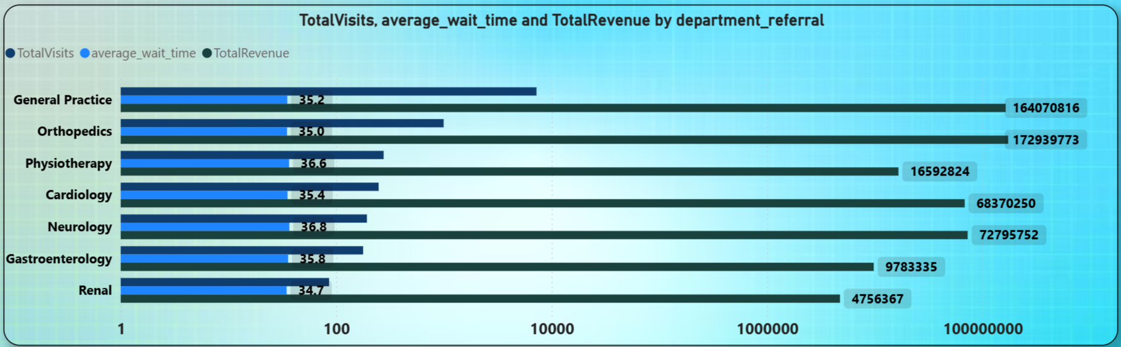
Insights
- General Practice
: Highest visits (7,240) and high revenue with moderate wait time (35.19 mins) → heavy patient load.
- Orthopedics
: High revenue but low visits (995) → specialized treatments, not workload-heavy.
- Neurology
: Low visits (193) but highest wait time (36.8 mins) → possible doctor shortage or longer consultations.
- Cardiology
: Similar to Neurology with low visits (248) but high wait time (35.3 mins).
- Physiotherapy & Gastroenterology
: Moderate visits and manageable wait times → no immediate need.
- Renal
: Lowest visits (86) and lowest revenue → no current need for additional staff.

Recommendations
- General Practice (Priority 1)
: Hire 1 doctor
: Reason → very high patient volume and demand.
- Neurology (Priority 2)
: Hire 1 doctor
: Reason → highest wait time, indicating service delay.
- Cardiology (Priority 3)
: Hire 1 doctor (optional)
: Reason → high wait time and specialized care needs.

- Is the hospital profitable? How will you determine the profitability?
Ans : Approach
- Indirect Profitability Assessment
: Since the dataset does not contain a direct Profit column, profitability was analyzed using revenue-related metrics.
- Calculated Revenue per Doctor
: Created a DAX measure to calculate Average Revenue per Doctor by department.
: AverageRevenueperDoctor = SUM(doctor_patients_data[Total Bill]) / DISTINCTCOUNT(doctor_patients_data[Doctor Name])

- Created Department Comparison Chart
: Used a bar chart to compare revenue generation efficiency across departments.
- Analyzed Revenue per Patient vs Wait Time
: Created measures for:
: Average Bill per Patient
: Average Wait Time
: Avg_Bill_per_Patient =
DIVIDE(
[TotalRevenue],
DISTINCTCOUNT('Hospital ER (1)'[patient_id]))
: average_wait_time = AVERAGE('Hospital ER (1)'[patient_waittime])

- Created Scatter Plot Visualization
: Used a scatter plot to analyze the relationship between operational efficiency and revenue generation.
: X-axis → Average Wait Time
: Y-axis → Average Bill per Patient
: Bubble Size → Average Satisfaction Score
: Legend/Color → Department Referral
- Compared Efficiency and Performance
: Evaluated the balance between revenue generation, service efficiency, and patient satisfaction.
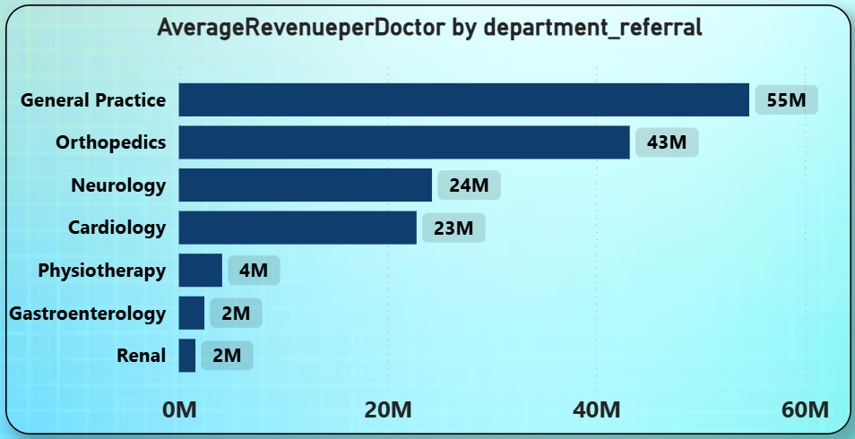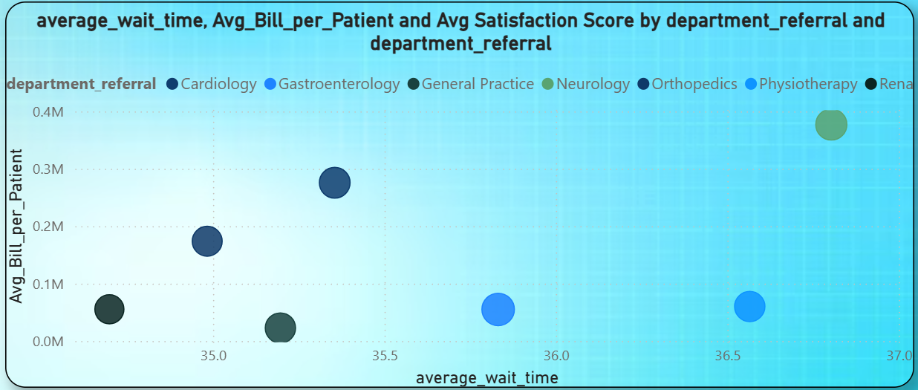

Insights
- General Practice and Orthopedics generate the highest revenue per doctor, indicating strong profitability and efficiency.
- Cardiology and Neurology generate moderate revenue but experience higher wait times.
- Physiotherapy, Gastroenterology, and Renal show lower revenue per doctor and lower patient contribution.
- Departments with higher wait times often show higher bills per patient, suggesting specialized or longer treatments.
- Overall, the hospital appears financially stable and profitable, mainly driven by high-performing departments.

Recommendations
- Invest in High-Performing Departments
: Strengthen General Practice and Orthopedics due to strong revenue contribution.
- Improve Operational Efficiency
: Reduce wait times in Neurology and Cardiology to improve throughput and satisfaction.
- Review Underperforming Departments
: Optimize staffing and services in low-revenue departments.
- Balance Revenue and Patient Experience
: Ensure profitability improvements do not negatively impact patient satisfaction.

- Any Department for which the waiting time is oddly large?
Ans : Approach
- Calculated Average Wait Time
: Created a DAX measure to calculate the average patient waiting time for each department.
: average_wait_time = AVERAGE('Hospital ER (1)'[patient_waittime])

- Created Visualization
: Used a bar chart with:
: X-axis → Department Referral
: Y-axis → Average Wait Time
- Compared Department Performance
: Analyzed average wait times across departments to identify unusual delays or bottlenecks.
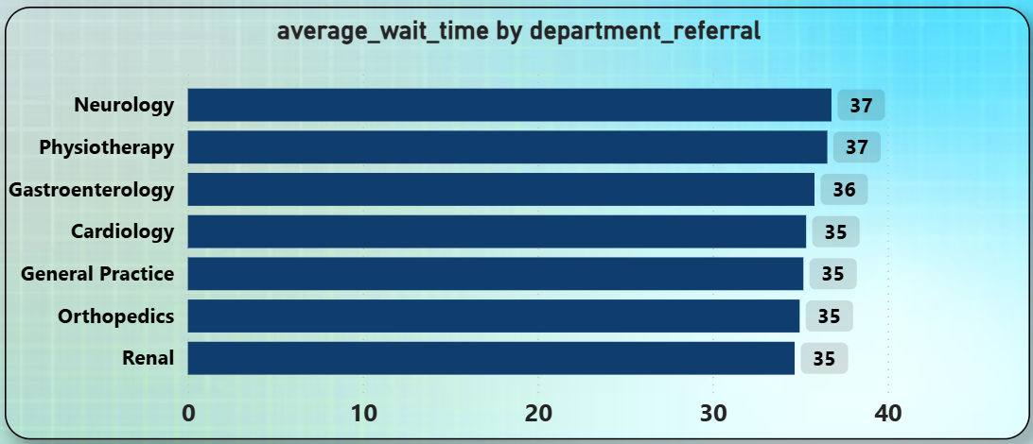

Insights
- No department shows an extremely high or abnormal waiting time compared to others.
- Most departments have average wait times within a similar range (35–37 minutes).
- Neurology and Physiotherapy have slightly higher wait times (around 37 minutes) than other departments.
- The higher wait times may indicate:
: Longer consultation durations
: Higher patient demand
: Scheduling or staffing inefficiencies
- Overall, the hospital maintains relatively balanced wait times across departments.

Recommendations
- Review Staffing and Scheduling
: Focus on departments with higher wait times and heavy workloads.
- Improve Appointment Management
: Introduce better scheduling and patient prioritization systems.
- Enhance Digital Booking
: Use online appointments and reminders to reduce overcrowding.
- Monitor Patient Feedback
: Collect feedback to identify operational issues causing delays.
- Continuous Performance Tracking
: Regularly monitor wait-time trends to prevent future bottlenecks.

- Come up with strategies to provide discounts to the patients.
Ans : Approach
- Extended Previous Discount Analysis
: Expanded the earlier age-group-based discount strategy by analyzing the Patient Race dimension.
- Created Visualization
: Built a Column chart in Power BI with:
: X-axis → patient_race
: Y-axis → TotalVisits
- Analyzed Patient Engagement
: Compared visit frequencies across racial groups to identify underrepresented groups with lower hospital engagement.
- Defined Discount Categories
: Classified racial groups into High, Medium, and Low discount categories based on visit volume.
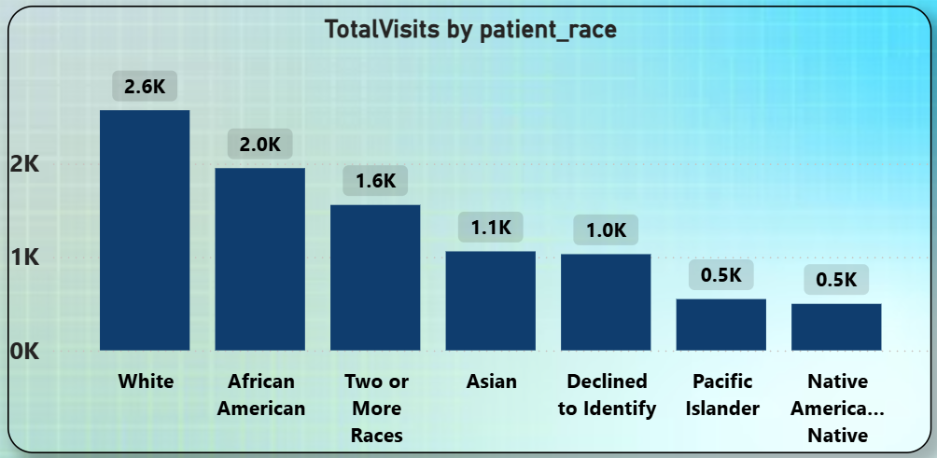

Insights
- White (2571 visits) and African American (1951 visits) groups show the highest engagement and hospital utilization.
- Two or More Races (1557 visits) and Asian (1060 visits) groups show moderate engagement.
- Pacific Islander (549 visits) and Native American/Alaska Native (498 visits) have the lowest visit frequency.
- The Declined to Identify (1030 visits) group shows average participation.
- Lower visit counts may indicate barriers to healthcare access or lower awareness among certain groups.

Recommendations / Discount Strategy
- High Discount (15–20%)
: Applicable for Native American/Alaska Native and Pacific Islander groups.
: Goal → Improve healthcare accessibility and increase engagement.
- Medium Discount (10%)
: Applicable for Asian and Two or More Races groups.
: Goal → Encourage higher participation and strengthen engagement.
- Low or No Discount
: Applicable for White and African American groups.
: Goal → Maintain retention and service satisfaction, as engagement is already high.

- Say you need to align the doctors of the “General Practice” department to work in one of the two shifts, how will you identify what will these two shifts' timings be, and how will you divide the doctors in these two shifts? And also will this 2 shift policy be helpful for the hospital?
Ans :
Approach
- Analyzed Hourly Visit Trends
: Extracted Hour from the DateTime column and plotted it against Total Visits.
- Applied Department Filter
: Filtered the analysis for the General Practice department only.
- Created Visualization
: Used a line chart with:
: X-axis → Hour of the day
: Y-axis → Total Visits
- Identified Peak and Low Hours
: Analyzed patient inflow patterns to determine optimal shift timings and staffing requirements.

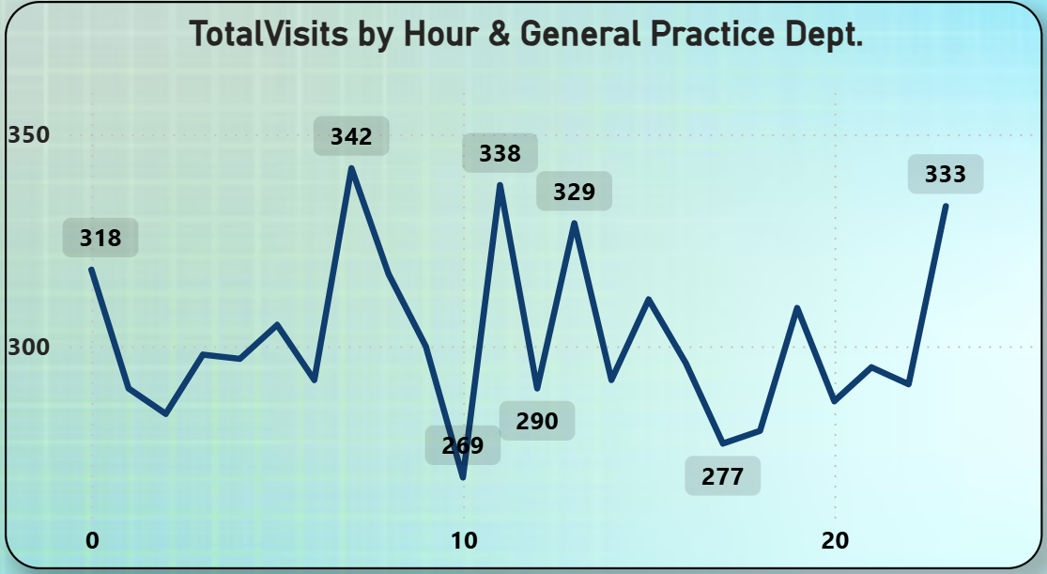

Insights
- Peak Hours
: Highest patient visits occur around 6 AM (342 visits), 11 AM (338 visits), and 1 PM (329 visits).
- Low Hours
: Lower patient inflow is observed around 10 AM (269 visits) and during 5 PM–8 PM (277–300 visits).
- Traffic Pattern
: Two major busy periods are visible:
: Early morning peak
: Midday peak
- Shift Transition Opportunity
: Mid-afternoon lower traffic provides a suitable handover period between shifts.

Recommended Shift Timings
- Shift 1 – Morning Shift
: 6 AM – 2 PM
: Covers the highest patient inflow hours during morning and midday.
- Shift 2 – Afternoon/Evening Shift
: 2 PM – 10 PM
: Covers afternoon consultations and evening operations.

Doctor Allocation Strategy
- Morning Shift
: Assign more doctors due to higher patient demand and peak-hour workload.
- Evening Shift
: Maintain fewer doctors with backup/on-call support if required.

Will the Two-Shift Policy Help?
: Yes, implementing a two-shift policy will be beneficial because it will:
- Improve doctor availability during peak hours.
- Reduce patient wait times and improve service efficiency.
- Balance doctor workload and reduce fatigue.
- Improve overall patient satisfaction and operational management.

- What do you understand by PowerBI gateway? What are its use cases?
Ans :
- Definition
: Power BI Gateway is a bridge that connects on-premises data sources to Power BI Service in the cloud.
- Purpose
: It enables secure and automatic data transfer without manually uploading data.
Types of Power BI Gateway
- Personal Mode Gateway
: Used by individual users for personal reports.
: Limited functionality and not suitable for sharing.
- Standard Mode (Enterprise Gateway)
: Used in organizations for multiple users.
: Supports scheduled refresh, DirectQuery, and live connections.
: Managed centrally for security and governance.

Use Cases
- Scheduled Data Refresh
: Automatically updates reports with the latest data from on-premises sources.
- Real-Time Connectivity
: Enables DirectQuery and live connections for real-time reporting.
- Hybrid Data Integration
: Combines cloud and on-premises data into a single report.
- Data Security
: Keeps sensitive data within the organization while securely transferring results.
- Collaboration
: Allows multiple users to access and refresh shared datasets.
Insights
: Power BI Gateway ensures secure, real-time, and automated data connectivity, making it essential for organizations working with on-premises data.

- How would you approach this problem, if the objective and subjective questions weren't given?
Ans : Approach
- Understanding the Dataset
: Started by reviewing tables like doctor_patients_data and hospital_er to understand structure and columns.
: Performed data profiling to check missing values, data types, and distributions.
- Exploring Key Areas
: Analyzed patient demographics (age, gender, race).
: Studied department performance (visits, satisfaction, revenue).
: Evaluated doctor performance (patient count, satisfaction, revenue).
: Examined time-based trends (monthly or seasonal patterns).
- Creating KPIs and Measures
: Defined metrics such as:
: Average Wait Time vs Satisfaction
: Total Revenue by Department/Doctor
: Patient Visit Frequency
: Average Satisfaction Score
- Data Visualization
: Used Power BI visuals for better insights:
: Line charts → trends over time
: Bar/column charts → comparisons across departments
: Scatter plots → relationships (e.g., wait time vs satisfaction)
: KPI cards → key metrics summary
- Insight Generation
: Identified patterns, trends, and problem areas from visuals.

Insights
- Data exploration helps uncover hidden patterns without predefined questions.
- Key focus areas like patient behavior, department performance, and trends naturally emerge.
- Visualization makes it easier to identify correlations and inefficiencies.
- A structured approach ensures data-driven decision-making even without guidance.

Recommendations
- Focus on exploratory data analysis (EDA) to guide problem identification.
- Build relevant KPIs based on business needs.
- Use interactive dashboards to explore multiple perspectives.
- Continuously refine analysis as new patterns or questions arise.

- Can you analyze and write the type of relationship between the doctor id and department, is it one-to-one?
Ans : Approach
- Created Summary Table
: Built a DAX summary table to count the number of departments associated with each Doctor ID.
- Analyzed Mapping
: Checked how many unique departments each doctor is linked to.
- Validated Relationship Type
: Identified whether each doctor belongs to a single department or multiple departments.

: Dr.RelationWithDept. = SUMMARIZE('doctor_patients_data',doctor_patients_data[Doctor Name],"TotalNoOfDept",DISTINCTCOUNT(doctor_patients_data[department_referral]))

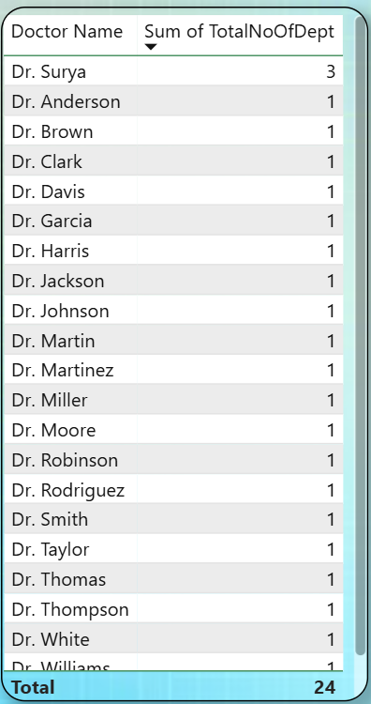

Insights
- Most doctors are associated with only one department, indicating a direct mapping.
- Dr. Surya is associated with multiple departments (3), showing an exception.
- This indicates that while the majority follow a one-to-one relationship, a few cases show a one-to-many relationship.

Conclusion
- The relationship between Doctor ID and Department is primarily one-to-one.
- However, due to exceptions like Dr. Surya, the overall relationship can be considered mostly one-to-one with slight one-to-many cases.
- This suggests that the hospital generally assigns doctors to one department, but allows flexibility for some doctors to work across multiple departments.

